# Focus Night And Day

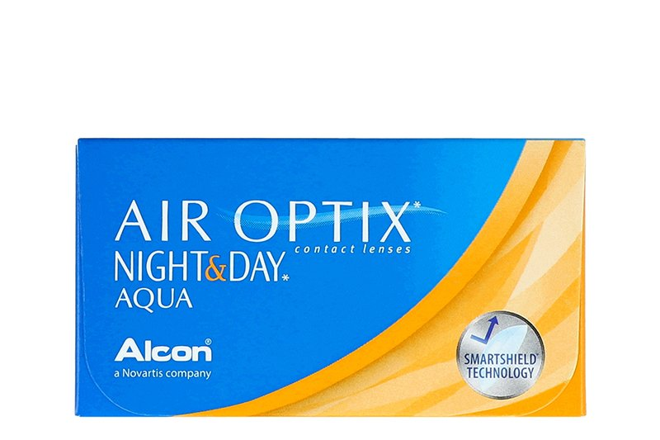

Product information

|  |  |
| --- | --- |
| **Brands** | Air Optix |
| **Availability** | IN STOCK |
| **Replacement** | 1 month extended wear |
| **Material** | 24% water, 76% lotrafilcon A polymer |

Description

**Air Optix Night and Day Aqua have replaced the former Focus Night and Day lens. You may continue to use your valid Night and Day prescriptions to order the Air Optix Night and Day Aqua. The new name/packaging reflects the improvements made to this contact lens.  
  
We will continue shipping the Focus Night and Day label until stock is depleted. Please note that you may receive the newer Air Optix Night and Day Aqua packaging.**